Quantum Computation and

Quantum Information Processing

RECAP on Teleportation 25.04.2019

STOP training based upon Umesh Vaziranis video *26 Teleportation part 2*

Name:_______________________________

* 1:20 What was Bob supposed to based upon the information send from Alice ?
* 1:33 What is the challenge for the time being
* 1:50 What does A&B share ?
* 2:27When A&B schall and connot share a CNOT what could Alice possibly do instead ?
* 2:27 Explain the reason why Alice is allowed to implement a CNOT on her site of the entangled system ?
* 3:00 What are the 2 initial values of Alices qubits – Please write in below for Q1 and Q2
* Q1 =_________________________________
* Q2 =_________________________________
* 3:29 Please write the TENSOR product of Q1⊗Q2
* Q1⊗Q2 =_____________________________
* _____________________________________
* 3:31What happens when You apply a CNOT from the first Qubit Q1 to the second qubit Q2
* [CNOT]Q1⊗Q2=_____________________________________________________________
* What part of the above is Alice going to measure ”IF Q2 = 0” - please describe below :
* _____________________________________
* What part of the above is Alice going to measure ”IF Q2 = 1” - please describe below:
* _____________________________________
* What must Alice tell Bob now ?
* ____________________________________
* What is Bob going to do about Alice’s info:
* IF it’s a 0 :
* ____________________________________
* IF it’s a 1 :
* ____________________________________

The Teleportation Protocol so far

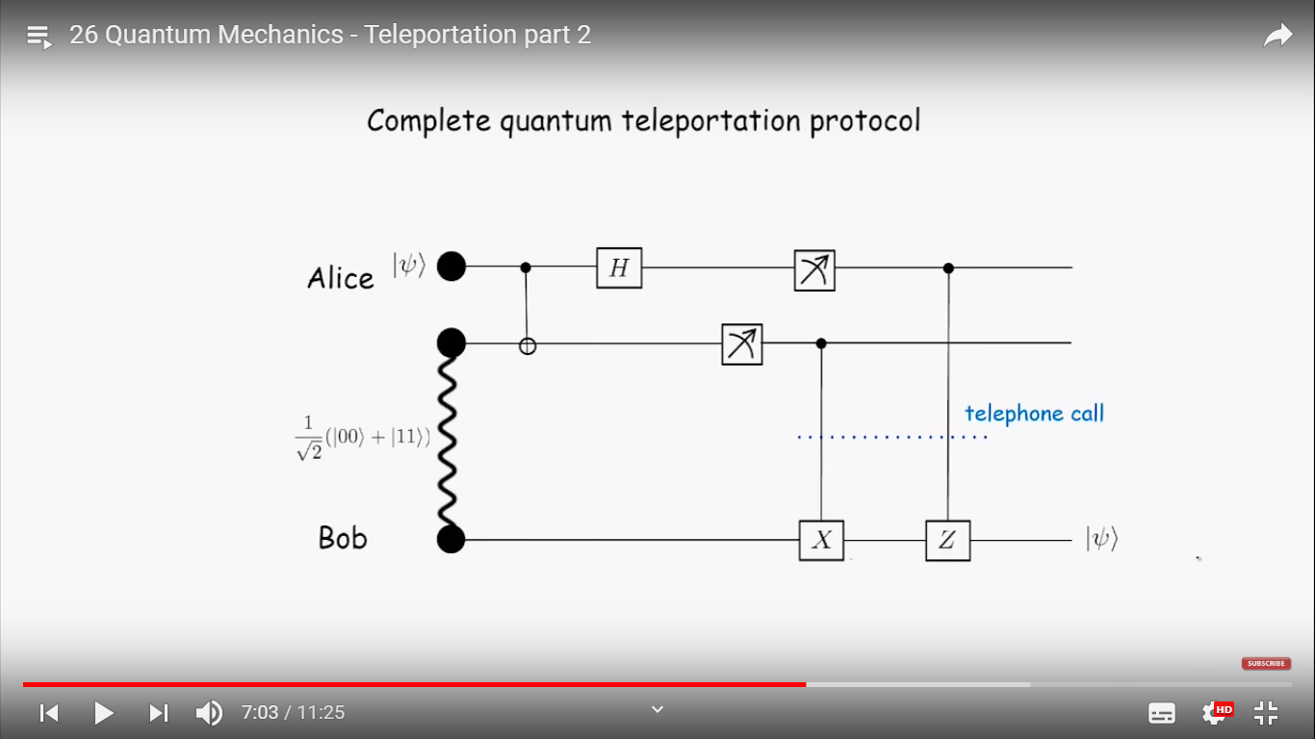

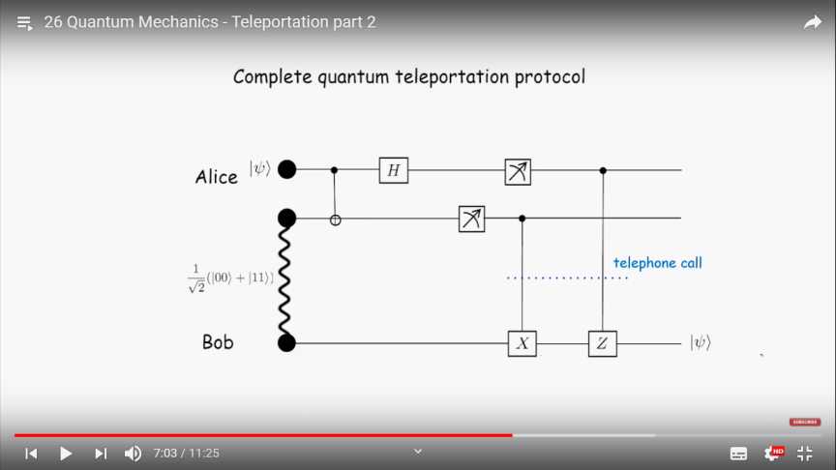

* 7:15 What belongs to Bob from picture ?



* 8:01 What sends Alice to Bob examplified by a Quantum Gate according to the picture ?



* 8:54 In what basis does Alice measure her Hadamard-Gate ?



* 8:01 So when Alice is not measuring in the PLUS/MINUS basis according to part 1 but in the bassis it turn out to be the same Yes/No ?



* 9:27 Why is the result of Bobs Output ?



* 9:47 Why this work ?



* 10:12 In what basis does Alice Measure Q1 ?



* 9:27 Where did the α and ß values from the original l ψ> be communicated to Bob ?

